AUCSC 218: Assignment #1: HTML5 + CSS

Due Wed Oct. 14, 2020

Overview
The intent of this assignment is to demonstrate your mastery of basic HTML and CSS.

Submitting
Put your assignment in a folder named assign1_yourFirstName. Put all resources used by your assignment into this folder. Zip this folder to the submit to eClass. You will lose marks if you do not follow these submission instructions.

Grading
The grade for this assignment will be broken down as follows:
Layout Accuracy (85/100)
Valid + Appropriately Semantic HTML (15/100)

Non-Functional Requirements
You must submit valid HTML5. The CSS files must be valid as well. You can use the W3C validator at http://validator.w3.org to ensure your HTML files are valid. You can use the CSS validator at http://jigsaw.w3.org/css-validator.
You must create the HTML web page shown below. You will be supplied with the necessary images. You must use CSS for formatting; however, other than some floats for either the menu or the action images in the table, CSS positioning will not be necessary. The page does not have to be an exact match; it should however be as close as possible and look the same on the major browsers.
The tabbed menu must be a list with different hover behavior (i.e., underline and different background image). For all links, make the destination URL simply be “#”. The table in the Table Template section should have its column sizes specified using relative percent measures.
There is a file called screen_capture.png which can be used to find colors. Notice that there are a variety of gradient images used as backgrounds (for table cells, text boxes, etc).

content_top.gif, content_bottom.gif
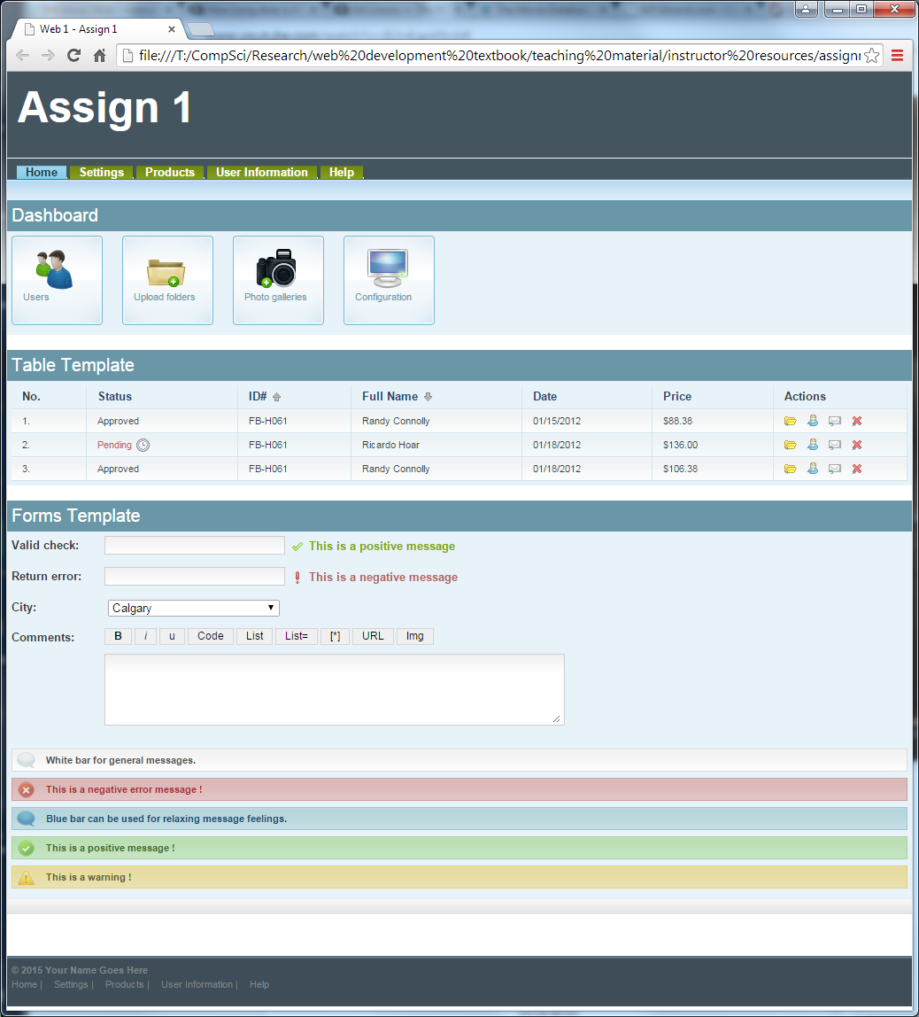
main_menu_li.gif, mm_lk_middle.gif
d1.gif, d2.gif, d3.gif, d4.gif, dashboard_li.gif
action1.gif, etc,
td_bg1.gif, td_bg2.gif, asc.gif, desc.gif, pending.gif
white_ico.png, white_message.gif,
red_ico.png, red_message.gif
blue_ico.png, blue_message.gif,
green_ico.png, green_message.gif
positive.gif, negative.gif, input_text1.gif, input_text2.gif
title_bg.png
Note: this should be an embedded table; each of these four things should be links

